The Effectiveness of Salaman Application-Based Service Innovations for Homeless Beggars in Bandung City
Gaston Otto Malindir^{1*}, Dede Sri Kartini², dan Rahman Mulyawan³
¹²³Government Science Postgraduate Study Program, Faculty of Social and Political Sciences, Padjadjaran University, Bandung, West Java, Indonesia
*Corresponding Author E-mail: otto.malindir@gmail.com
Abstract
As a form of service innovation, the Bandung City Population and Civil Registration Service applies Salaman application-based services. The word Salaman itself is an abbreviation of the word finished in hand. In practice, the Salaman application-based service implemented by the Department of Population and Civil Registration throughout 2019-2021 raises its own problems, especially for certain groups, such as homeless people, beggars, and other marginal groups in the city of Bandung. The purpose of this study was to analyze and describe the effectiveness of the service innovation of the Population and Civil Registration Service based on the Salaman application for the homeless and beggar groups. This research uses a descriptive method with a qualitative approach. Data collection techniques are carried out through interviews, observation and documentation, and data analysis techniques are carried out by data reduction, data display and drawing conclusions. The results of this study indicate that of the seven indicators used to measure the effectiveness of service innovations implemented by the Department of Population and Civil Registration of Bandung City, six of them showed poor results associated with groups of homeless people and beggars in the city of Bandung. The six indicators include clarity of purpose, clarity of strategy, process of policy analysis and formulation, careful planning, programming, and effective and efficient implementation. So overall it can be concluded that the Salaman application-based service innovation has not been effective in its application, especially if it is associated with groups of homeless people and beggars in the city of Bandung.
Keywords: Effectiveness, Service Innovation
Abstrak
Sebagai bentuk inovasi pelayanan maka Dinas Kependudukan dan Pencatatan Sipil Kota Bandung memberlakukan pelayanan berbasis aplikasi Salaman. Kata Salaman sendiri merupakan singkatan dari kata seleSAi daLAm gengaMAN. Dalam pelaksanaannya, pelayanan berbasis aplikasi Salaman yang diterapkan oleh Dinas Kependudukan dan Pencatatan Sipil sepanjang tahun 2019-2021 memunculkan permasalahan tersendiri khususnya bagi kelompok tertentu, seperti gelandangan, pengemis, maupun kelompok marginal lainnya yang ada di Kota Bandung. Tujuan dari penelitian ini adalah untuk menganalisa dan mendeskripsikan tentang efektivitas dari inovasi pelayanan Dinas Kependudukan dan Pencatatan Sipil berbasis aplikasi Salaman bagi kelompok gelandangan dan pengemis. Adapun penelitian ini menggunakan metode deskriptif dengan pendekatan kualitatif. Teknik pengumpulan data dilakukan melalui proses wawancara, observasi dan dokumentasi, dan Teknik analisia data dilakukan dengang reduksi data, display data dan penarikan kesimpulan. Hasil penelitian ini menunjukan bahwa dari ketujuh indikator yang digunakan untuk mengukur efektivitas dari inovasi pelayanan yang diterapkan oleh Dinas Kependudukan dan Pencatatan Sipil Kota Bandung, enam diantaranya menunjukan hasil yang kurang baik dikaitkan dengan kelompok gelandangan dan pengemis yang ada di Kota Bandung. Enam indikator tersebut antara lain kejelasan tujuan, kejelasan strategi, proses analisis dan perumusan kebijakan, perencanaan yang matang, penyusunan program, serta pelaksanaan yang efektif dan efisien. Maka secara keseluruhan dapat disimpulkan bahwa inovasi pelayanan berbasis aplikasi Salaman belum efektif dalam penerapannya, lebih khususnya jika dikaitkan dengan kelompok gelandangan dan pengemis yang ada di Kota Bandung.
Kata Kunci: Efektivitas, Inovasi Pelayanan

INTRODUCTION
Public service is an effort made by a group or a bureaucratic person to provide assistance to the community in order to achieve a certain goal. Of the various services implemented by government agencies, the population administration service is one that is quite dominant (Di & Pasirjambu, 2017). One of the government agencies engaged in public services, namely the Population and Civil Registration Service, which is in charge of providing services to the community related to the management of identity cards, or birth certificates whose needs are increasing every year (Hisbani et al., 2015).
In the context of good governance, public services are the main gate of government bureaucratic reform, so it needs special attention both by the government itself and the community. Public service is one of the activities where the bureaucracy or government apparatus can interact actively with community groups. In this New Public Service era, public services must be more responsive because they will be directly monitored in a transparent manner by the public. Therefore, it is necessary to innovate services from government agencies as implementers.
Public service innovation is one of the central themes in the discipline of public administration. According to Rogers, innovation is an idea, practice, or object that is considered new by an individual or other unit of adoption. In practice, innovation is one of the government's efforts to support the achievement of the vision of bureaucratic reform (Melinda et al., 2020). This public service innovation is currently being paid attention to by all government agencies both at the central and regional levels, and the City of Bandung is one of them.
The city of Bandung is one of the largest metropolitan cities in the province of West Java, as well as being the capital of the province of West Java. The city is located 140 km southeast of Jakarta, and is the largest city in the western part of Java Island. Meanwhile, the Greater Bandung area (Bandung Metropolitan Area) is the third largest metropolitan area in Indonesia after the Jabodetabek area and the Gerbang kertosusila area.
As a form of service innovation, the Bandung City Population and Civil Registration Service applies Salaman application-based services. The word "Salaman" itself is an abbreviation of the word "finished in hand" which shows simple activities that can be done easily by anyone anywhere with just a cellphone/smarphone device.
In practice, the Salaman application-based service implemented by the Department of Population and Civil Registration throughout 2019-2021 raises its own problems, especially for certain groups, such as street children, beggars, and other marginal groups in the city of Bandung. This is due to economic conditions that do not support them to have cellphones/smartphones or other electronic devices as well as internet quotas as an alternative to getting Salaman services either through applications or websites.
Data from the Central Statistics Agency for the City of Bandung shows that the Poverty Line in the City of Bandung continues to increase every year, at 500,452 in 2020. This shows that, even though as the capital city of West Java Province, Bandung City cannot be separated from social welfare problems in which this group will be affected. find it difficult to adapt to the transformation of Salaman application-based services implemented by the Bandung City Population and Civil Registration Service.
On the other hand, the condition of the Covid-19 pandemic that has emerged in Indonesia since the beginning of 2020 until now has become one of the factors for the increasing problem of Social Welfare in the city of Bandung, which is not only experienced by marginal groups such as homeless people, beggars, street children, but also middle economic groups. down during the Covid-19 Pandemic. This will certainly have an impact on the administration of government in the city of Bandung, more specifically with regard to services based on the Salaman application.
These are some of the obstacles to service innovation based on the Salaman application, which basically requires supporting access to both cellphones/smartphones and Internet quotas. Considering the substance of public services, which can meet every public need for public goods, this will be a separate problem, especially for marginal groups in the city of Bandung.
Specifically, problems related to the effectiveness of service innovations from the Office of Population and Civil Registration based on the Salaman application for homeless beggar groups in Bandung can be seen from several aspects that become measures of effectiveness ranging from clarity of goals to be achieved, clarity of strategy for achieving goals, process analysis and formulation solid policies, careful planning, preparation of appropriate programs, availability of work facilities and infrastructure, as well as effective and efficient implementation. Based on these problems, this paper aims to determine the effectiveness of the Salaman application-based service innovation implemented by the Department of Population and Civil Registry, especially for the homeless-beggar group in Bandung City during 2019-2021.

RESEARCH METHOD
This study uses a descriptive method with a qualitative approach to explore and analyze the phenomenon of service innovation based on the Salaman application which is carried out by the Department of Population and Civil Registration of Bandung City. This is in line with what was stated by Creswell (Wisler, 2009) “Qualitative research is a means for exploring and understanding the meaning individuals or groups ascribe to a social or human problem. The process of research involves emerging questions and procedures, data typically collected in the participant’s setting, data analysis inductively building from particulars to general themes, and the researcher making interpretations of the meaning of the data. The final written report has a flexible structure. Those who engage in this form of inquiry support a way of looking at research that honors an inductive style, a focus on individual meaning, and the importance of rendering the complexity of a situation”.
Data collection techniques are methods used by researchers to collect data needed to solve research problems. The data collection techniques in the study are interviews, observation, questionnaires, and documentation (Abubakar, 2021). The data analysis techniques used in this research are data reduction, data display and conclusion drawing. As stated by Sugiyono (Wisler, 2009) in the process of data analysis carried out simultaneously with data collection, meaning that researchers in collecting data also analyze data obtained in the field. Activities in data analysis are: data reduction, data display, and conclusion drawing/verification.

RESULT AND DISCUSSION
Overview of Salaman Application-Based Services
In order to provide population administration services to the community in the city of Bandung, the Population and Civil Registry Office issued several service innovation products by utilizing existing technological developments and one of them is the Salaman application-based service which was launched in 2018 and has been implemented since early 2019. The word Salaman itself is an abbreviation of complete in hand, which means that all services needed by the people of Bandung City can be done only through their electronic devices. In this Salaman-based service, several types of services are available, ranging from birth certificates, death certificates, information on moving out, and child identity cards that can be accessed by the public without having to go to the Bandung City Population and Civil Registry Office.
Figure 1. The service menu on the Salaman application
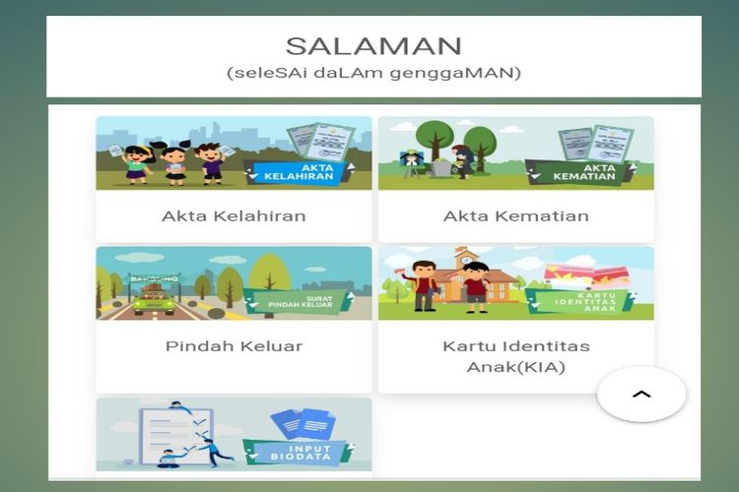
Source: https://disdukcapil.bandung.go.id/
From the picture, it can be seen that several types of services are available on the Salaman application, starting from birth certificates, death certificates, moving out certificates, data input and child identity cards that can be accessed by all people in Bandung. With the Salaman application, residents no longer need to queue and wait long to take care of population administration services, but can be directly accessed online through the Bandung City Population and Civil Registration Service website. In addition, this application is held with the aim of reducing queues during the population administration service process at the Bandung City Population and Civil Registry Service, so that the public is facilitated by being able to access services from anywhere using their electronic devices.
To gain access to the above, people only need to provide electronic devices such as cellphones, laptops, or cellphones with the help of the internet to be able to access the desired population administration services. This is considered very easy and practical because people no longer have to come to the Population and Civil Registry Office to get the desired service but can be done anywhere in accordance with the rules and service times that have been set.
From the data from the Bandung City Population and Civil Registration Office report that during 2020, the number of people who access and even apply for population administration services through the Salaman application is quite low, one of which is the birth certificate service.
Graph 1. Submission of a Birth Certificate at the Salaman Service in 2020
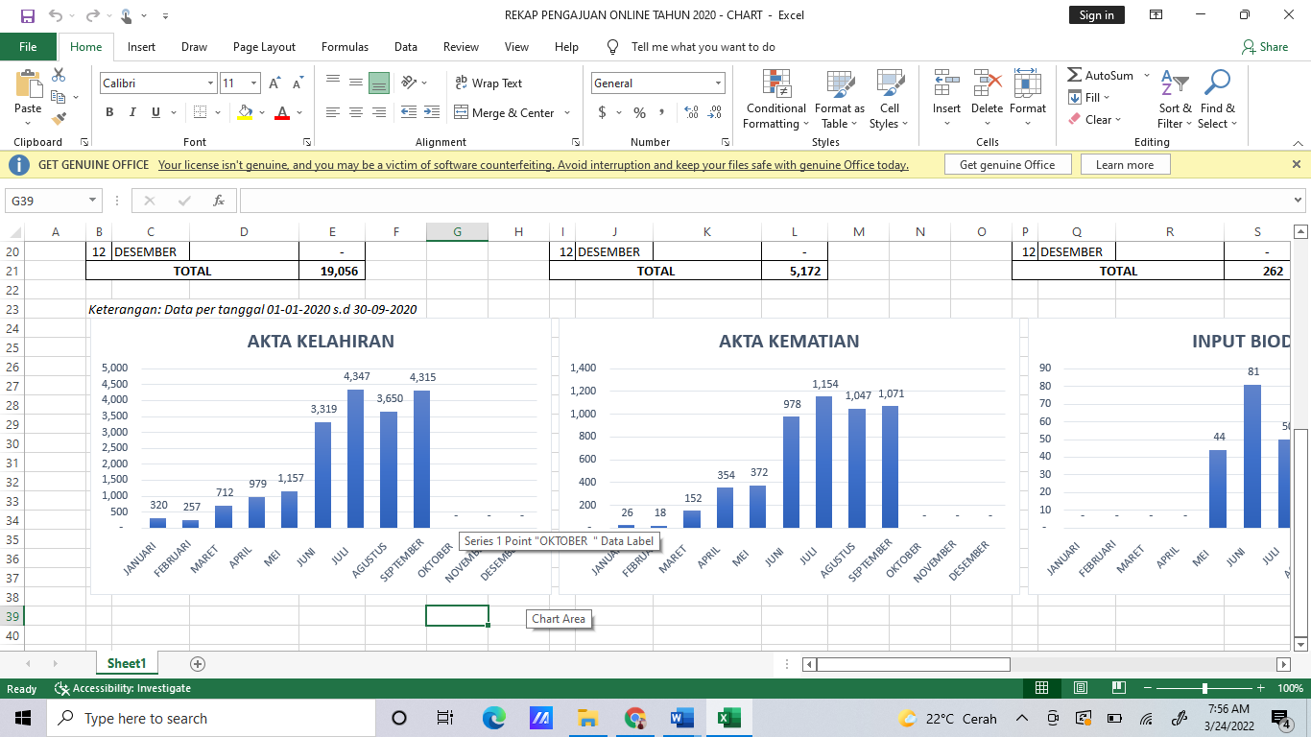
Source: Data from the Department of Population and Civil Registration of Bandung City
The data above shows that the low level of public access to service innovations based on the Salaman application which is implemented by the Department of Population and Civil Registration of Bandung City. During 2020, it was recorded that people who accessed Salaman-based population services to process birth certificates were only massive in June-September and tended to be few at the beginning of the year and almost no one had access during October-December. Given that a birth certificate is one of the most important demographic data for a child to be recognized as an Indonesian citizen and for other administrative needs, of course, it will be very much needed by the community. However, in practice, the majority of the people of Bandung City have not been able to access birth certificate services through the Salaman application as shown in the data above.
Some of the problems faced by people who have not been able to access Salaman services are related to supporting electronic devices and internet access which is an alternative to reach Salaman application-based services. One of the community groups who experience these problems is a group of homeless people and beggars in the Bandung City area. The problem of service innovation based on the Salaman application can be seen from several aspects such as clarity of purpose, clarity of strategy, process of analysis and policy formulation, careful planning, program preparation, availability of work facilities and infrastructure, as well as effective and efficient implementation.
Clarity of Purpose
An innovation can be said to be effective if it has clear objectives that the implementer wants to do, in this case the Bandung City Population and Civil Registration Office. With regard to research conducted on services based on the Salaman application, the goal must be clear and able to target all groups in society, including the homeless beggar group in Bandung City, as stated by the Head of the Service Innovation Division of the Bandung City Population and Civil Registration Service.
The results of research in the field show that the Salaman application-based service has not been running in accordance with the predetermined goals because it has not been able to answer some of the needs of the community, especially the homeless beggar group for population administration services, both birth certificates, death certificates, moving-out certificates, and identity cards. child. With the online service method using electronic devices and the help of internet quotas, it is difficult for groups of homeless beggars to access these services. Their economic condition is the main factor for this group to find it difficult to access and receive Salaman-based services. This is inversely proportional to the purpose of presenting the Salaman application-based service innovation, which is to make it easier for all the people of Bandung City to receive population administration services that can be done anywhere and anytime so that people do not need to spend time to come to the Bandung City Population and Civil Registration Office.
Table 1. Recapitulation of the Number of Death Certificate Submissions in 2020
No | Month | Service Name | Amount
1 | January | Death Certificate | 26
2 | February | Death Certificate | 18
3 | March | Death Certificate | 152
4 | April | Death Certificate | 354
5 | May | Death Certificate | 372
6 | June | Death Certificate | 978
7 | July | Death Certificate | 1.154
8 | August | Death Certificate | 1.047
9 | September | Death Certificate | 1.071
10 | October | Death Certificate | -
11 | November | Death Certificate | -
12 | December | Death Certificate | -
Total |  |  | 5,172
Source: Bandung City Population and Civil Registration Service
The data above shows that very few people in Bandung have access to death certificate services through the Salaman application. Based on these data, it can be seen that the highest number was only at 1,047 – 1,154 submissions during the months of July – September, while the submissions at the beginning of the year were very low at 26 submissions. The data above also shows that at the end of 2020, namely in October-December, there were no submissions made by the public for death certificate services through the Salaman application.
That way, the purpose of the presence of Salaman application-based service innovation has not been running properly and has not been in accordance with the conditions of the people of Bandung City as the beneficiaries of the service. This phenomenon shows that the goals set by the Bandung City Population and Civil Registration Service do not use a socio-economic approach to the community so that it is potentially not right on target or cannot be fully perceived by the people of Bandung City, one of which is a group of homeless beggars who also have the same right to receive services.
Based on the results of observations made, it shows that the population administration service based on the Salaman application has not been able to be felt by all the people of the City of Bandung from various groups so that it shows that the purpose of presenting the Salaman application-based service has not been achieved. If you use the theoretical approach proposed by Siagian (Han & goleman, daniel; boyatzis, Richard; Mckee, 2019) then the innovation of the Bandung City Population and Civil Registration Service based on the Salaman application is not yet fully effective because it does not meet the size of the clarity of goals to be achieved.
Strategy Clarity
Apart from the clarity of objectives, the service innovations presented must also meet the size of the strategy clarity. Related to this research, the size of the strategy relates to a separate way carried out by the Bandung City Population and Civil Registration Office as the executor so that all people can feel the benefits of the services provided. This strategy can be oriented to things that are technical in nature, one of which is providing other alternatives to the people of Bandung City who have difficulty accessing services based on the Salaman application, one of which is a group of homeless beggars.
The results of research in the field show that the strategy used by the Salaman application-based service implementer is not clear because it has not been able to target all groups, one of which is homeless beggars. No other option was given as part of the strategy of the Department of Population and Civil Registration so that gangs and beggars in Bandung City can also benefit from services such as providing electronic public facilities for those who do not have access. The procedures offered in the Salaman application-based service seem convoluted and lengthy, making it difficult for the community.

Figure 2. Salaman Application Service Flow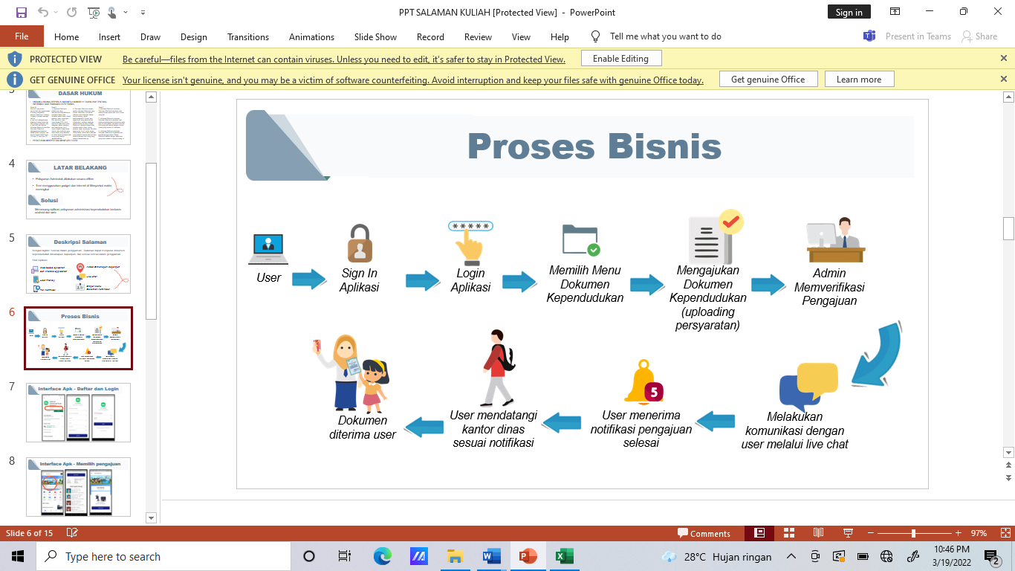
Source: Bandung City Population and Civil Registration Service
The picture above shows that the flow offered to the public through the Salaman application is quite long and seems difficult. In addition to the demands to understand the use of technology, the public must also follow a series of processes starting from logging in and creating an account, logging in to the application, selecting the population document menu, until the document is received. Even though the services offered are online, to get the documents that have been accessed, the public must visit the Bandung City Population and Civil Registration Office in order to get them. The procedure is even more complicated than manual or direct services. This shows that the strategy taken by the implementer can be said to have not been effective in making it easier for the community to take care of population administration.
Furthermore, based on observations, it shows that the agency as the executor does not have a clear strategy related to population administration services based on the Salaman application which has been implemented since 2019-2021 which has an impact on groups of homeless beggars who have not fully accessed these services. Referring to the theory put forward by Siagian, the service innovation in this case the Salaman applied by the Department of Population and Civil Registration can be said to be ineffective because it has not been able to meet the size of the strategy clarity. The Department of Population and Civil Registration can further simplify the services provided so that they can be accepted by the entire community, including homeless and beggar groups.
Policy Analysis and Formulation Process
In order to make an innovation, careful analysis and formulation are needed by involving all parties, both implementers and the community as the target of the policy or program to be implemented. In connection with this research, the analysis process implies that the Department of Population and Civil Registration as the executor must first see and understand the conditions in the field so that the innovation of services based on the Salaman application that will be proposed really becomes a necessity and answers community problems.
The results showed that the initial analysis process was not carried out by the Office as the executor, so that the basis for the problem of the emergence of Salaman-based service innovation was not quite right. The initial analysis should be carried out as best as possible by the implementer to collect the problems that occur and the factors that influence it so that the innovations that will be raised are those that are able to answer problems in the field related to population administration services.
In terms of policy formulation, the implementers do not involve representatives from all groups so that the Salaman application-based service innovation is only able to answer the needs of some community groups while others are not affordable and even do not feel the benefits of the services provided, one of which is the homeless and beggar groups in the city of Bandung. . As stated in Law no. 25 of 2009 (Rehamn and Sultana, 2009) regarding public services that "The implementation of public services is based on one of the principles of equality of rights", so that what happened in the City of Bandung related to Salaman-based services is contrary to the rules of public service. applicable.
Based on the results of observations made, it shows that the analysis and policy formulation process is not carried out properly with various considerations by the Population and Civil Registration Service so that the Salaman application-based service innovation launched since 2018 has not been able to target some community groups, one of which is homeless beggars in the city. Bandung. Referring to the theory put forward by Siagian (Han & goleman, daniel; boyatzis, Richard; Mckee, 2019) then an innovation can be said to be effective if it meets the size of the analysis process and mature policy formulation. Therefore, it can be said that the Salaman application-based service applied in the city of Bandung cannot be said to be an effective innovation.
Careful planning
In order to realize a service innovation, careful planning is needed so that what is the goal of the innovation itself. In general, the success of implementing a service innovation is largely determined by good planning, as well as the innovation of population administration services based on the Salaman application which is implemented in the city of Bandung. At the planning stage, the Department of Population and Civil Registration of Bandung City as the executor as much as possible analyzes every factor and opportunity that exists.
The results of research in the field indicate that the planning carried out by the implementing agency is not mature enough so that in its application, the Salaman application-based service innovation has not been able to answer the needs of the people of Bandung City as a whole, one of which is the homeless beggar group. This is proven by the difficulty of groups of homeless beggars to access Salaman-based population administration services as a result of the limited access they have, both electronic access, both cellphones, laptops, and internet access. This shows that the planning carried out does not consider various aspects that exist in the community, both homeless and beggars.
Figure 3. Initial Stages of Accessing Salaman Application-Based Services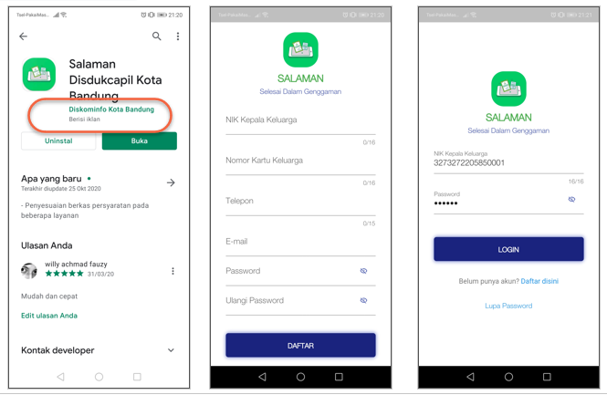
Source: Bandung City Population and Civil Registration Service
From the picture above it shows that the Bandung City Population and Civil Registration Service has designed that to be able to access population administration services, the public must first download the Salaman application on the Playstore and after that they can enter the home page to fill in their personal data before submitting the desired and available service. on the Salaman application-based service menu. This initial process will make it more difficult for the community, especially the homeless and beggar groups because apart from having limited access, they also have to face online procedures that they have not done before.
Based on the results of observations made related to the innovation of population administration services based on the Salaman application, it was found that the planning carried out by the implementer was not appropriate so that the people of Bandung City as the target of the service did not fully feel the service innovation which was their right as a citizen. Referring to the effectiveness measure theory proposed by Siagian (Han & goleman, daniel; boyatzis, Richard; Mckee, 2019) then the Salaman application-based service innovation implemented in Bandung City can be said to be less effective because it has not met a mature planning measure. Therefore, there is a need for evaluation and improvement steps from the implementer so that the Salaman application-based service can answer the needs of the entire community in the city of Bandung, including the homeless and beggar group.
Programming
To support an innovation to be implemented and run effectively, it is necessary to arrange several work programs to support it. The program in this case is intended to support the effectiveness of implementing service innovations based on the Salaman application which has been implemented by the Department of Population and Civil Registration for the people of Bandung City from 2018-2021. It is in this stage of program preparation that it will determine whether the innovation of Salaman application-based services can run according to the predetermined goals or vice versa.
The results of the study indicate that until now there has been no program developed in order to encourage the effectiveness of Salaman application-based services. The Department of Population and Civil Registration as the executor only relies on lower government agencies such as sub-districts and regional apparatus organizations in the city of Bandung to accommodate people who want to get population administration services.
The impact is that some community groups in the city of Bandung such as homeless people and beggars have not been able to feel the benefits of the Salaman application-based services that are presented. The preparation of this program should be carried out optimally so that Salaman application-based services can reach all social groups in the community and are able to provide other alternatives to those who have difficulty accessing these services, one of which is the homeless beggar group in the city of Bandung. Given that innovation is a development effort carried out by referring to what has been done, the Salaman application-based service must be more accessible and can be felt by all community groups in the city of Bandung, including the homeless and beggars.
Based on the results of observations made, it is not clear what programs are prepared and implemented to support the implementation and effectiveness of Salaman application-based services. This phenomenon has not just happened for the first time in service innovations that are being implemented, but also occurs in several other population administration service innovations implemented by the Bandung City Population and Civil Registration Service, such as e-Space, e-Punten, Fast Fighting, and Youth services. Therefore, if viewed from the aspect of program preparation that has not been going well, the innovation of Salaman application-based services has not been effective.
Availability of Work Facilities and Infrastructure
In an effort to streamline an innovation that will be or is being implemented, supporting facilities and infrastructure are needed. In connection with the innovation of population administration services based on the Salaman application, facilities and infrastructure are needed to support the implementation of the desired goals. On the other hand, the importance of this infrastructure is aimed at helping the people of the City of Bandung to obtain and receive benefits from the service innovations provided by the Department of Population and Civil Registration.
The results of research in the field indicate that the work support facilities available to assist the implementation of service innovations from the Bandung City Population and Civil Registration Service are complete. As a city with the status of the Capital City of West Java Province, the City of Bandung has shown its feasibility as a reference for 26 other regencies/cities with its service support facilities. Apart from the work support facilities available at the office, the executor in the service is also assisted by a mobile car called Mapeling which stands for Providing Mobile Services. Mapeling is a mobile service program (pick up the ball) to bring services closer to people who cannot visit the Bandung City Population and Civil Registration Office or who cannot access online-based services independently.
Figure 4. Mapeling Service Car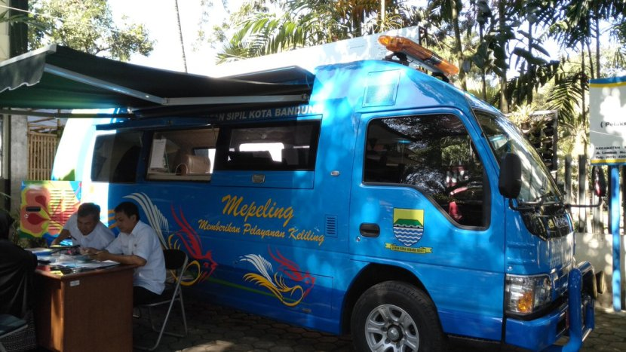
Source: Bandung City Population and Civil Registration Service
The picture shows that the service process is also carried out at various points in the city of Bandung by car. This innovation is another alternative offered by the Department of Population and Civil Registration to people who cannot provide services directly at the office or online (independently). This shows that the implementing agency makes certain efforts, one of which is to pick up people who want to perform population administration services.
Based on the results of observations made, it shows that the facilities and infrastructure for implementing work are adequate in supporting the effectiveness of the innovation of population administration services based on the Salaman application. Although the available facilities and infrastructure are classified as complete as supporting services, in reality they have not been able to be maximized so that the administrative services provided by the Population and Civil Registration Service are able to answer the needs of all community groups including the homeless beggar group in the city of Bandung. As for other facilities and infrastructure, such as the availability of the network in the city of Bandung, it is very adequate so that it cannot be used as a reason for the Salaman application-based service that is applied to be constrained or cannot be felt by the whole community.
Effective and Efficient Implementation
Implementation is the stage that determines whether a service innovation provided by the implementing government agency can be felt by the whole community and runs effectively as expected or vice versa. Likewise, the Salaman application-based service has been implemented since 2019 by the Bandung City Population and Civil Registration Service. So it is necessary to observe and know the extent to which the effectiveness of the applied service innovations. To see the effectiveness of the Salaman application-based service, it is necessary to refer to the initial goals that have been set with what happened in the implementation.
Based on the results of the study showed that the application of Salaman application-based services could not be said to be effective. This is based on some community groups, namely homeless beggars who have not been able to access and feel the benefits of these services. This marginal group also with limitations and existing economic conditions makes it increasingly difficult for them to receive population administration services, most of which are already application-based. This phenomenon is inversely proportional to the presence of application-based services, one of which is Salaman, which is presented by the Department of Population and Civil Registration, which is to make it easier for the public to receive services that are faster, more efficient and can be done anywhere only through their electronic devices.
On the other hand, the public services provided are the rights of the entire community, especially the city of Bandung which is based on equal rights so that it is not appropriate if the service innovations applied have not been able to be felt by a community group. Of course, this is contrary to the principles and principles of public service so that basic improvements are needed by the implementer in this case the Population and Civil Registration Service so that all groups including homeless beggars can feel the services provided so that service innovation can be said to be effective.

CONCLUSION
Based on the description of the discussion above, it can be concluded that the service innovation of the Population and Civil Registration Service based on the Salaman application in Bandung City has not been effective. This is based on the services provided that have not been able to be accessed and felt by all parties, one of which is the homeless and beggar groups. The purpose of presenting population administration services based on the Salaman application is to provide services that are easier, more effective and efficient. However, in reality, this goal is inversely proportional to the conditions of application in the field, which is due to economic limitations and access that makes it difficult for homeless beggar groups to access and feel the benefits of these services.
This is of course contrary to the principles and principles of public services, namely convenience and equality of rights, which means that with the phenomenon that there are still groups that have not been able to access service innovations implemented by the Bandung City Population and Civil Registration Service, the service cannot be said to be effective. Furthermore, the process of formulation and preparation of services does not involve the community so that the resulting service products are not able to answer all the needs of the people of Bandung City for population administration services.
There needs to be an evaluation step carried out by the Bandung City Population and Civil Registration Office as the executor to find out what are the obstacles and obstacles during the implementation of service innovations so that they can be improved so that they are more effective and accessible to all groups including homeless beggars when applied again after the implementation of the Siak trial. centered. The implementing agency also needs to provide supporting infrastructure such as service access centers at several points in the city of Bandung with the aim of being an alternative support for people who do not have electronic devices or internet access to get services based on the Salaman application provided.

REFERENCES
Abubakar, R. (2021). Introduction to Research Methodology. In Antasari Press.
Di, K., & Pasirjambu, K. (2017). The quality of public services in the field of population administration in the Pasirjambu sub-district. 2, 56–65.
Han, E. S., & goleman, daniel; boyatzis, Richard; Mckee, A. (2019). Effectiveness. Journal of Chemical Information and Modeling, 53(9), 1689–1699.
Hidayah, D. D. (2020). QUALITY OF PUBLIC SERVICES (Study of Population Administration Services in Cipatujah District, Tasikmalaya Regency). Dynamics: Scientific Journal of Public Administration, 7(1), 28–34.
Hisbani, N. A., Karim, M., Malik, I., Ilmu, J., Negara, A., Unismuh, F., Ilmu, J., Negara, A., Unismuh, F., Ilmu, J., Negara, A., & Unismuh, F. (2015). ENREKANG DISTRICT. 1.
Ilmu, J., Publik, A., & Riau, U. (2021). PUBLIC SERVICE INNOVATION THROUGH THE INVESTMENT POTENTIAL APPLICATION SYSTEM ( SIAPI ) IN THE INVESTMENT AND SERVICES OFFICE. 3(September), 215–226.
Melinda, M., Syamsurizaldi, S., & Kabullah, M. I. (2020). Innovation of Online Population Administrative Services (PADUKO) by The Department of Population and Civil Registration of Padang Panjang City. Master: Journal of Government Science, 19(2), 202–216. https://doi.org/10.35967/njip.v19i2.115
Paradigma, J., & Prakoso, C. T. (2020). Public service innovation at the Population and Civil Registry Office of Kutai Kartanegara Regency in the perspective of digital government 1. 9(2), 131–146.
Publik, P., & Belakang, A. L. (2013). Effectiveness of Public Services in Kendahe District, Sangihe Regency. Governance, 5(1), 1–13.
Rehamn and Sultana, 2011. (2009). No Title كتاب المجامع. مجلة العربية, 2(5), 255. ??
Wisler, A. K. (2009). ‘Of, by, and for are not merely prepositions’: teaching and learning Conflict Resolution for a democratic, global citizenry. Intercultural Education, 20(2), 127–133. https://doi.org/10.1080/14675980902922143

